**Code Coverage**

We implemented Unit Tests, but not using any set framework. Instead we implemented a custom TestRunner. Our code coverage is limited to the move validation. Here’s a summary of the few tests we did implement:  
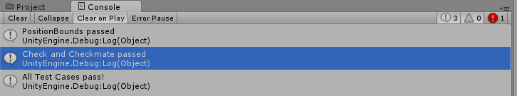

The script that runs the tests is called TestRunner - all of the tests are in a folder called TestScripts which is under Assets in the project folder.